**WELCOME TO**

**KNOWLEDGE**

**SHOTS**

Topic of the day :

**DESIGN PATTERNS IN**

**JAVA**

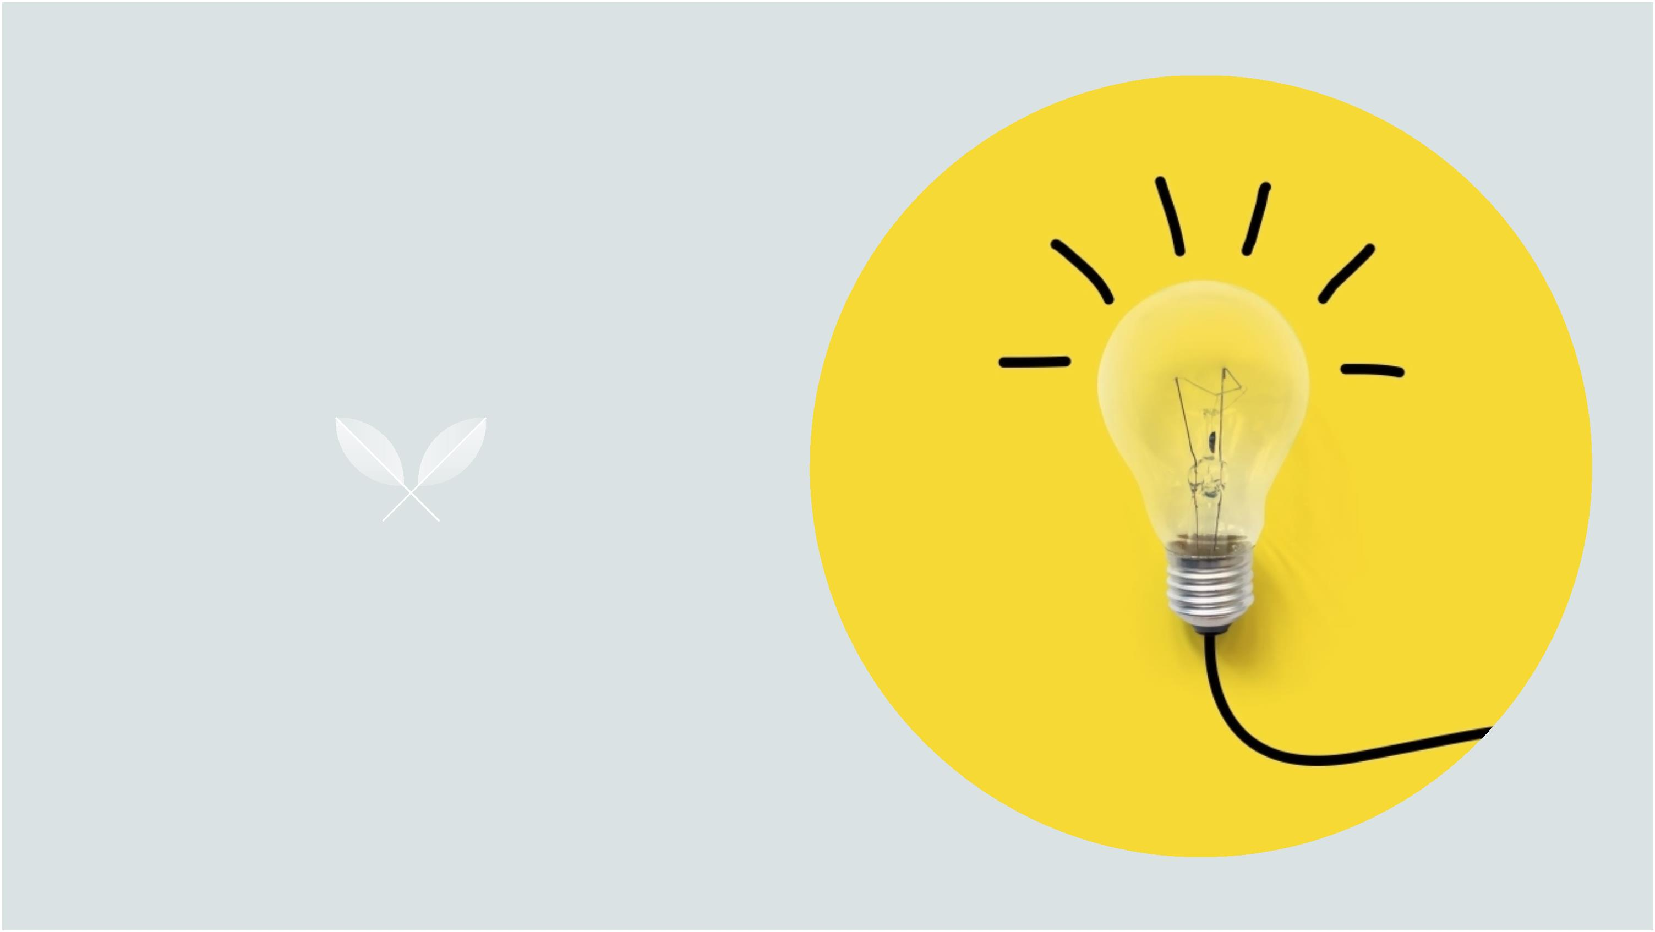

**What are design patterns?**

It is a description or template for how to solve a

problem that can be used in many different situations.

Ø Best practices

Ø Solutions to general problems

Ø Common platform for developers



**What are some of the Design**

**Patterns?**

vCreational

vStructural

vBehavioural



**What are some of the Design**

**Patterns?**

v**Creational**

vStructural

vBehavioural



These design patterns are all about class

instantiation or object creation.



**Types of Creational Design**

**Patterns**

§ Factory Method

§ Abstract Factory

§ Builder

§ Singleton

§ Object Pool

§ Prototype.



**Types of Creational Design**

**Patterns**

§ **Factory Method**

§ Abstract Factory

§ Builder

§ Singleton

§ Object Pool

§ Prototype.



In Factory pattern, we create

object without exposing the

creation logic to client and the

client use the same common

interface to create new type of

object.



Thank You

